Console Banking Application
Student Question Guide
Use these questions to guide students step by step. Keep the session question-led. Let students think, answer, and build each part.

Part 1 - First Output
- How can you show the bank name in the console?
- How can you show a welcome message under the bank name?
- How can you print a simple line above and below the welcome message?
- How can you make the console output look like a small banking screen?
- 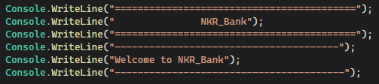

Part 2 - Store Bank Details
- How can you store the bank name in the program?
- How can you store the account holder name?
- How can you store an account number?
- How can you store the account balance?
- Which data type is better for storing money?
- How can you print the account holder name with a label?
- How can you print the account number with a label?
- How can you print the current balance with a label?
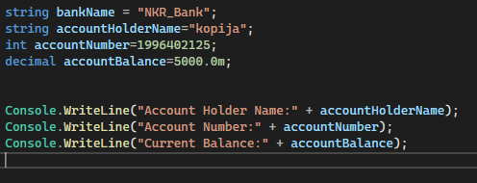

Part 3 - Get User Input
- How can you ask the user to enter their name?
- How can you read the name typed by the user?
- How can you store the typed name in a variable?
- How can you print a greeting using the entered name?
- How can you ask the user to enter an opening balance?
- How can you read the opening balance entered by the user?
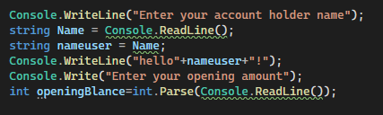

Part 4 - Display Account Details
- How can you display all account details together?
- How can you display the account holder, account number, and balance on separate lines?
- How can you format the balance to show two decimal places?
- How can you clear the console before showing account details?
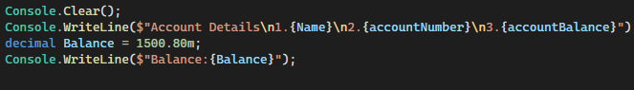

Part 5 - Create a Menu
- What options should a simple banking app show to the user?
- How can you print a menu with options such as View Account, Check Balance, Deposit, Withdraw,and Exit?
- How can you ask the user to choose a menu option?
- How can you store the selected option?B
- How can you show a message based on the selected option?
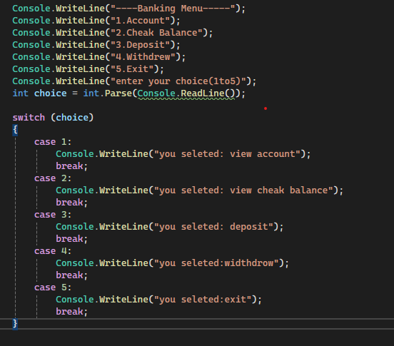

Part 6 - Make Decisions
- If the user enters 1, how can you show account details?
- If the user enters 2, how can you show the balance?
- If the user enters 3, how can you start the deposit process?
- If the user enters 4, how can you start the withdrawal process?
- If the user enters a wrong option, how can you show an invalid choice message?
- How can you rewrite the menu selection using a switch statement?
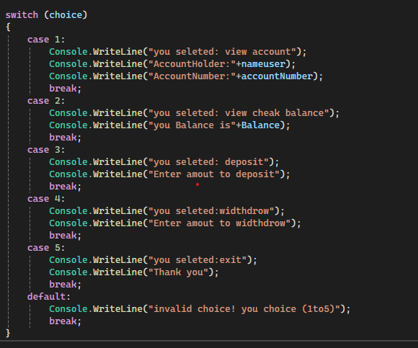

Part 7 - Deposit Money
- How can you ask the user to enter a deposit amount?
- How can you convert the entered deposit amount into a number?
- How can you check whether the deposit amount is greater than zero?
- How can you add the deposit amount to the current balance?
- How can you show the updated balance after deposit?
- What message should appear if the deposit amount is invalid?
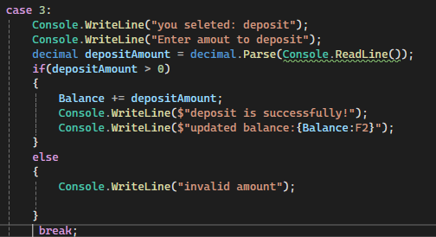

Part 8 - Withdraw Money
- How can you ask the user to enter a withdrawal amount?
- How can you check whether the withdrawal amount is greater than zero?
- How can you check whether the user has enough balance?
- How can you subtract the withdrawal amount from the balance?
- How can you show the remaining balance after withdrawal?
- What message should appear if the user does not have enough balance?
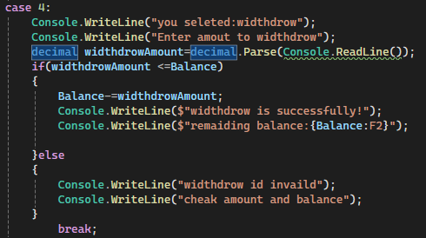

Part 9 - Repeat the Application
- How can you keep showing the menu until the user chooses Exit?
- Which loop can be used to repeat the menu?
- How can you stop the loop when the user chooses Exit?
- How can you pause the screen before returning to the menu?

- How can you clear the screen before showing the menu again?

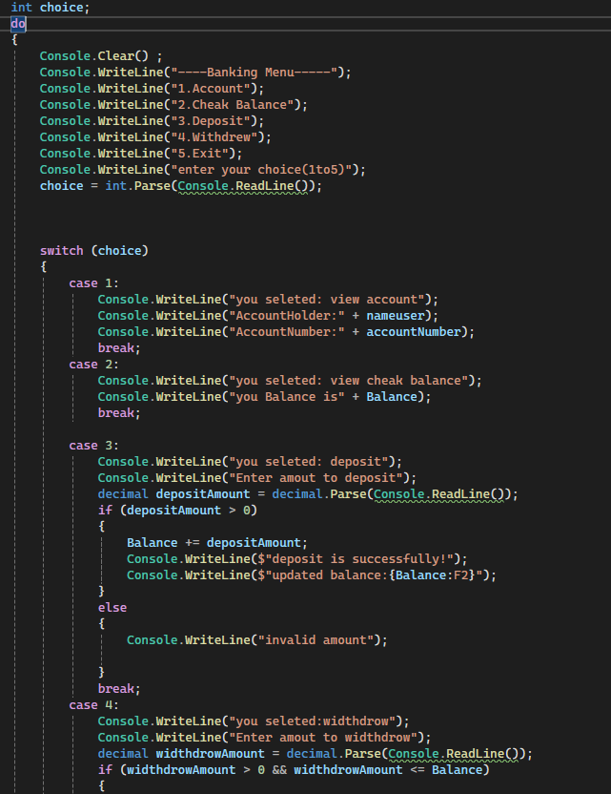 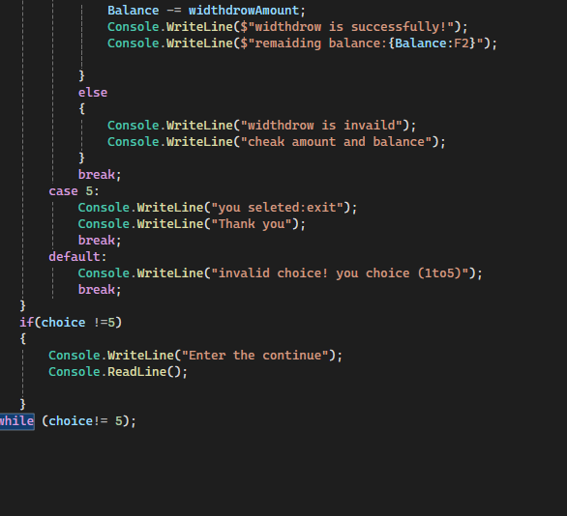 Part part 10 - Organize the Code
- How can you move the welcome message into a separate method?
- How can you move the menu display into a separate method?
- How can you move account details display into a separate method?
- How can you move deposit logic into a separate method?
- How can you move withdrawal logic into a separate method?
- Why is it better to split the program into methods?
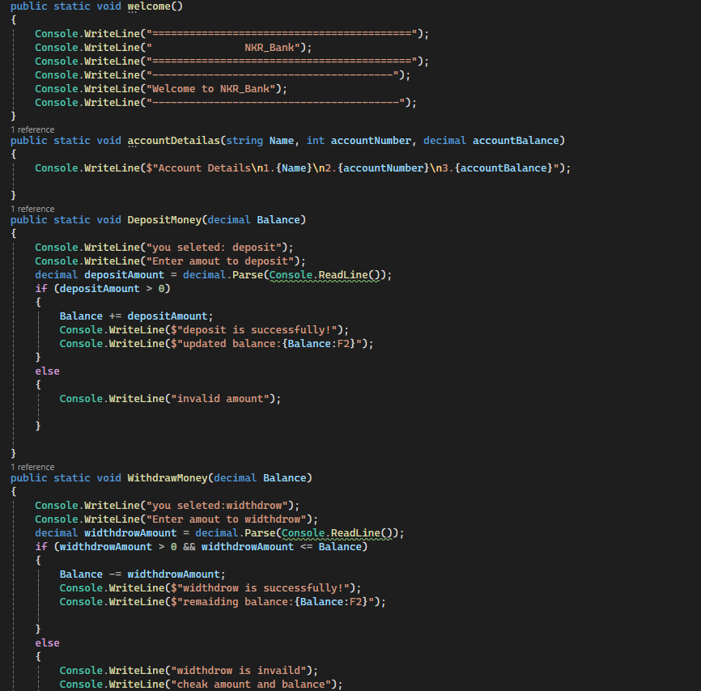

Part 11 - Create a Bank Account Object
- How can you create a class called BankAccount?
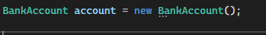
- What properties should a BankAccount have?
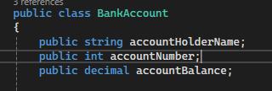
- How can you create a BankAccount object?
- How can you store account holder, account number, and balance inside the object?
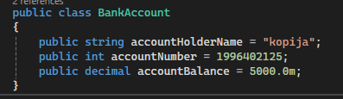
- How can you print details from the BankAccount object?

Part 12 - Add Banking Actions to the Class
- How can you create a Deposit method inside the BankAccount class?
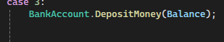
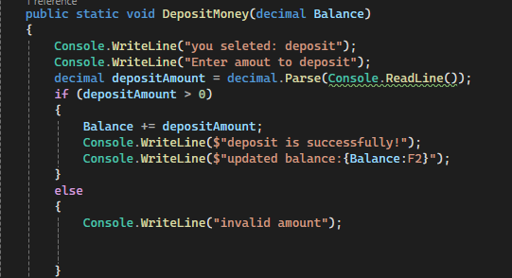
- How can you create a Withdraw method inside the BankAccount class?
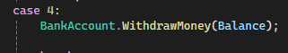
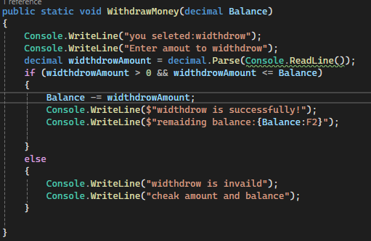
- How can the Withdraw method return true or false?
- How can the balance be protected from being changed directly?
- How can the console menu call the Deposit and Withdraw methods
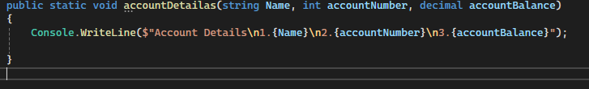

Part 13 - Transaction History
- How can you store many transaction records?
- How can you add a message when money is deposited?
- How can you add a message when money is withdrawn?
- How can you show all transactions to the user?
- What should be shown if there are no transactions yet?
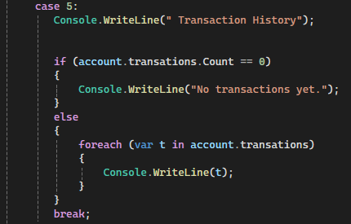

Part 14 - Final Console Banking App
- Can the user create or view an account?
- Can the user check the balance?
- Can the user deposit money?
- Can the user withdraw money?
- Can the user view transaction history?
- Can the user exit the application?
- Does the application handle invalid menu options?
- Does the application handle invalid money values?
- Is the banking logic separated from the console display logic?

Part 15 - Prepare for WPF Migration
- Which parts of the app are only console UI?
- Which parts of the app are banking logic?
- Which methods can be reused in WPF?
- Which console inputs will become text boxes in WPF?
- Which console menu options will become buttons in WPF?
- Which console outputs will become labels or text blocks in WPF?
Quick Lesson Path
- Print bank name and welcome message.
- Store account holder, account number, and balance.
- Read user input.
- Show account details.
- Build a menu.
- Handle choices.
- Add deposit.
- Add withdrawal.
- Repeat until exit.
- Split into methods.
- Create BankAccount class.
- Move banking logic into the class.
- Add transaction history.
- Identify what can be reused in WPF.

Minimal Teaching Rule
Ask one question, let students answer, then code only that small part.

